**Introduction & Motivation**

**Introduction**

Nowadays, smart-device is a part of human life. Over the past few years, the demand for smart-device has grown exponentially as companies develop increasingly advanced software and features. Popular mobile phone apps have truly revolutionized the entire mobile phone industry.

In the near of future smart-device will carry everything about user to make human more convenient. So, we want to develop some application to support human life. This application can be used for payment or identification the user smart-device. And we will use NFC technologies to develop it. NFC orknown in Near field communication is a set of standards for smartphones and similar devices to establish radio communication with each other by touching them together or bringing them into proximity, usually no more than a few centimeters. Present and anticipated applications include contactless transactions, data exchange, and simplified setup of more complex communications such as Wi-Fi. Communication is also possible between an NFC device and an unpowered NFC chip, called a "tag". [1] Our application will be able to run on any mobile device operating system.

**Motivation**

According to the statistical of credit and debit payment reference from retailing banker website, we know that the number of people who use credit or debit card instead banknote is increasing. [2] So, we want to develop our system that able to be integrated with the credit or debit card to solve the problem that occurred from using banknote and coin such as hygienic, currency exchange, change and etc. It will give the user more convenient and diversity useful.

**Aims and Objectives**

**Aims**

The aim of this project is to develop the communications protocols which is the near field communication (NFC) on the smart phone. NFC is a standard technology in smartphone that use to establish radio communication with each other by touching them together.

The main purpose of NFC is to use in the contactless payment systems. Instead of paying with cash or credit cards, the user can use the smartphone for payments, loyalty programs, card access, transit passes, and other custom services by using NFC-based transactions. [1]

**Objectives**

* To use the smartphone as the payment method.
* To reduce the payment process by using the smartphone.
* To make the NFC widely use in the transaction payment method.

**Identification and challenging issues**

**Security**

Issues – Eavesdropping. Eavesdropping occurs when attacker intercepts the signal sent between two devices. They would have access to that person’s credit card information. Viruses, the hacker may making them a target, producing the viruses to steal information from users. [3]

Solution – To protect users against these security risks. Users can also take their own precautions to protect their personal information by involving a PIN and One-Time-Password. The second is the design of NFC security issues. Making them hard to access to prevent the hacker stealing the information. [4]

**Development**

Issues – The NFC technology based on radio-frequency identification (RFID) standards but NFC supports encryption, so, developer might concern about security of the payment systems. Because it contain the private information of the user, such as, number of credit card, password, and, etc. [5]

Solution – To solve this problem, the developer should learn more and practice

**Project Plan**

**Technology review**

1. **Phonegap**

PhoneGap is a mobile development framework that enables software programmers to build applications for mobile devices using JavaScript, HTML5, and CSS3, instead of device-specific languages such as Objective-C. It enables wrapping up of HTML, CSS and Javascript code depending upon the platform of the device. [6]

1. **PHP**

PHP: Hypertext Preprocessor, a scripting language used to create dynamic and interactive HTML Web pages. A server processes PHP commands when a website visitor opens a page, then sends results to the visitor’s browser. [7]

**Development Methodology**

Scrum is an agile methodology that can be applied to our project. The Scrum process is suited for projects with rapidly changing or highly emergent requirements. Scrum software development progresses via a series of iterations called sprints. The Scrum model suggests each sprint begins with a brief planning meeting and concludes with a review. [8]

**Deliverables**

|  |  |  |
| --- | --- | --- |
| **Identity** | **Operation** | **Time Duration** |
| Proposal | Mobile Wallet: Proposal | 25 August 2014 – 30 August 2014 |
| 1st progress | - Card Register system  - Account system | 1 September 2014 – 30 September 2014 |
| 2nd progress | - Security system  - NFC Censor system | 1 October 2014 – 30 October 2014 |
| 3nd progress | - Profile & Pasteboard system  - User Interfaces | 1 November 2014 – 30 October 2014 |

Proposal – due day 1st sept 2014, presentation day 5th sept 2014

1st progress

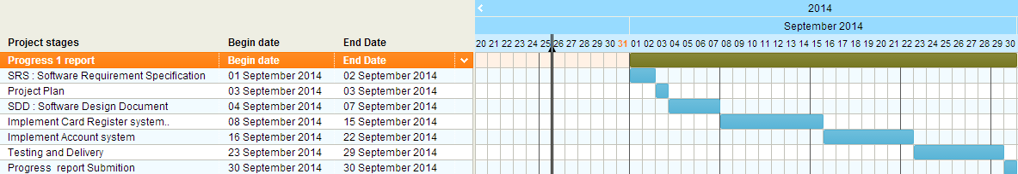

2nd progress

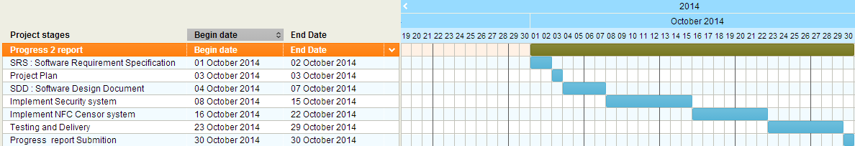

3nd progress

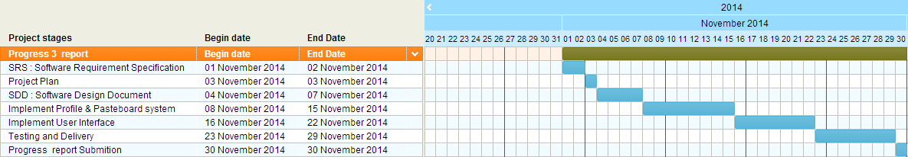

**Project Management**

The purpose of the Project Management process is to establish and carry out in a systematic way the Tasks of the software implementation project, manage constraints, and version control which allows complying with the project’s objectives in the expected quality, time and cost.

**Team Roles**

|  |  |  |
| --- | --- | --- |
| **No.** | **Participants** | **Roles** |
| 1 | Mr. Manuchet Manoi | Software Design |
| 2 | Mr. Passakorn Buadee | Developer |
| 3 | Mr.Witsaras Suninhong | Developer |
| 4 | Mr. Saknarong Noipaksa | Tester |
| 5 | Mr. Supawit Kamjina | Project Manager |
| 6 | Mrs. Yanhua Li | Requirement Analyst |

* Everyone in group can review another work

**Constrains 1. Budget**

1.1 Cloud server hosting 1.2 Google Play Store deployment

**2. Resources**

2.1 Smart phone devices 2.2 NFC sensors

**Version Control Strategy**

The Mobile Wallet (NFC) use the Github for repository to keep tracking the project artifacts. The name of document will be named as following format: [9]

“[Project Name]-[Document Name] _ [Version]. [File Type]”

**Project Impact**

|  |  |
| --- | --- |
|  | **Description(level[High/Medium/Low])** |
| **Advantage** | **Consumer:**   * NFC mobile wallet can card one more, can achieve unity machine card.[H] * NFC mobile wallet make consumers pay more convenient, save a lot of time cost.[H] * Mobile phone no electricity, can also be NFC payments[M]   **Retailer:**   * NFC mobile wallet can reduce business costs and the required personnel.[H]   NFC technology will be conducive to marketing, pricing, sales , can better evaluate shopping behavior.[M] |
| **Disadvantage** | * Mobile phones can only be read against the chip card electronic wallet information limited, and cannot transfer operation.[M]   NFC mobile wallet also bring larger safe hidden trouble, easy cause consumer bank card information.[H] |

|  |  |  |
| --- | --- | --- |
| **Risk statement** | **Risk solution** | **Priority** |
| Demand is not clear | Through let users to participate in the development, develop the user interface prototype, demand discussion meeting, strengthen the demand analysis and review to solve. | High |
| Project the lack of visibility | Through iterative development, technology review, continuous integration to solve | High |
| Technical compatibility risk | Clear related technical parameters and configuration requirements of the equipment. In the early stages of the development work, do technical compatibility test. | High |
| Software usability problems | Collaborate with users to ensure that the user can be found early usability issues, such as timely correcting. Analysis of the strengths and weaknesses of competitive products. Set by the user interface standards, consistency, to avoid a system there are many different style of interface. | Medium |

**Risk Management**

**References**

[1] http://en.wikipedia.org/wiki/Near_field_communication

[2] http://retailbanking.theasianbanker.com/assets/media/dl/whitepaper/Increasing%20Debit%20Card%20Utilization%20and%20Generating%20Revenue%20using%20SUPER%20Segments.pdf

[3] http://www.nearfieldcommunication.org/nfc-security-risks.html

[4] http://www.nfcworld.com /category/applications/payments

[5] http://www.mobilepaymentstoday.com /topics/contactless-nfc

[6] http://en.wikipedia.org/wiki/PhoneGap

[7] http://www.techopedia.com/definition/24406/php-hypertext-preprocessor-php

[8] http://www.mountaingoatsoftware.com/agile/scrum

[9] https://github.com/

**Mobile Wallet (NFC System)**

Project Proposal

By

**Mr. Passakorn Buadee 542115048**

**Mr. Manuchet Manoi 542115049**

**Mr.Witsaras Suninhong 542115058**

**Mr. Saknarong Noipaksa 542115061**

**Mr. Supawit Kamjina 542115064**

**Mrs. Yanhua Li XXXXXX**

Department of Software Engineering

College of Arts, Media and Technology

Chiang Mai University

Lecturer

**Prof. Hongnian Yu**